24k-0918 DSA LAB 09 Output
Task-0
Why AVL?
An AVL tree keeps the binary search tree balanced so that the height difference between left and right subtrees never exceeds one.
This balance makes searching, insertion, and deletion faster compared to an unbalanced BST.

Step-by-Step Explanation
- The function starts from the root and first balances the left and right subtrees using recursion.
- After balancing both sides, the height of each node is updated as one plus the maximum height of its children.
- The balance factor (difference between left and right heights) is calculated for each node.
- If the balance factor is greater than 1 or less than -1, the node is unbalanced and needs rotation.
- Depending on the case (LL, RR, LR, or RL), appropriate rotations are performed to restore balance.

Explanation of Temporary Pointers in Rotations
- In the right rotation, y is the unbalanced node, x is its left child, and t2 is the right child of x.
- In the left rotation, x is the unbalanced node, y is its right child, and t2 is the left child of y.
- These temporary pointers help to rearrange links safely without losing any subtree during rotation.

Type of Rotations
- Left-Left (LL): Right rotation
- Right-Right (RR): Left rotation
- Left-Right (LR): Left rotation on child, then right rotation
- Right-Left (RL): Right rotation on child, then left rotation
Node Returned at the End
At the end of the function, the root of the newly balanced subtree is returned.
If a rotation was performed, the new root after rotation (like x or y) is returned.
If no rotation was needed, the same node is returned.
This ensures that the final tree is height-balanced from bottom to top.
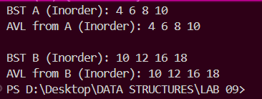
Task-1
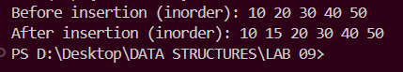
Task-2
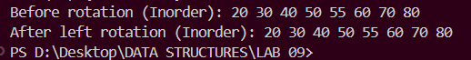
Task-3
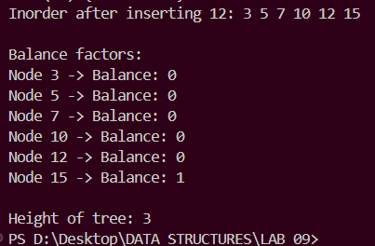
Task-4
